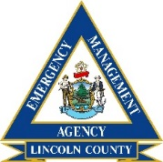
Lincoln County
Emergency Management Agency

2021 Team Schedule

Local EMA Directors (3rd Thursday EOM)
January 21st, 2021 1800 via Zoom
March 18th, 2021 1800 via Zoom
May 20th, 2021 1800 via Zoom
August 19th, 2021 1800 @ TBA
October 21st, 2021 1800 @ TBA

SAR (2nd Monday, quarterly)

February 8th, 2021 1800 via Zoom
May 10th, 2021 1800 via Zoom
September 13th, 2021 1800 @ TBA
December 13th, 2021 1800 @ TBA

LEPC (3rd Thursday, quarterly)
January 21st, 2021 1400 via Zoom
April 15th, 2021 1400 via Zoom
July 15th, 2021 1400 @ TBA
October 21st, 2021 1400 @ TBA

DST (bi-annually)

April 15th, 2021 TBD @ TBA
June 17th, 2021 TBD @ TBA

ART- Amateur Radio Team (2nd Wednesday)
All ART Meetings are at 1800 hrs, @ the Newcastle F.D.

February 10th, 2021 August 11th, 2021
April 14th, 2021 October 13th, 2021
June 9th, 2021 December 8th, 2021

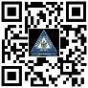
*all dates & times are subject to change with notice.

