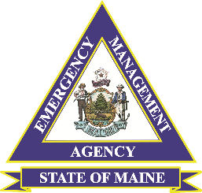

**\*Private Non-Profits (PNP’s):** Education, medical, custodial care, emergency (fire departments, search and rescue, and ambulances), utility, and other (museums, community centers, libraries, homeless shelters, senior citizen centers, health and safety services) institutions.

**Reimbursement Activities may Include:**

* Force Account Labor – overtime, premium pay, and compensatory time costs based on pre-disaster written labor policies
* Force Account Equipment and Purchased Equipment
* Leased Equipment
* Supplies – include materials needed to respond or recover from incident or taken from stock and used for incident
* Mutual Aid Costs
* Donated Resources (volunteer organizations must track resources and work performed, including descriptions, specific locations, and hours

**Purpose**

On March 13, 2020, the President declared the ongoing Coronavirus Disease 2019 (COVID-19) pandemic of sufficient magnitude to warrant an emergency declaration pursuant to section 501 (b) of the Robert T. Stafford Disaster Relief and Emergency Assistance Act, 42 U.S.C. 5121-5207.

Reimbursement efforts include emergency protective measures to save lives, to protect public health and safety, and to protect improved property are eligible.

**Applicant Eligibility:**

* State, Local Governments, Tribes, and certain Private Non-Profits*
* Potential Applicants will be required to submit a Request for Public Assistance (RPA) in FEMA’s Grants Portal
* Each applicant must have a minimum of **$3,300** in recorded damages
* Exclude anticipated insurance pay-outs

**No Duplication of Assistance:**

Eligible Emergency Protective Measures taken in response to this emergency, and not supported by the authorities of another federal agency such as the Department of Health and Human Services, including the Centers for Disease Control and Prevention, will be reimbursed under the FEMA Public Assistance Program.

**FEMA-3444-EM – COVID-19**

**Public Assistance Program Eligibility:**

Category B – Emergency Protective Measures

**Funding:** FEMA assistance will be provided at a 75 percent federal cost share. This declaration does not provide financial assistance to individuals.

PA Fact Sheet